Julie Mennes

AI: science or technology?

# THE ROAD TO DOMAIN EXPERTISE

Familiarize with a domain

* Specialized terminolgy of jargon
* Theories and methods
* Values

Acquire domain knowledge

* **Explicit**: you can describe it, know that, theoretical. Reading a coooking book
* **Tacit**: know-how implicit, you might not even be aware, pratical. Follow a recipe from your grandma

# Expertise

Good at solving problems that fall in their domain of expertise

All problem solving

Develop a mental representation of problem, in terms of available problme-solving strategies

**chuncking**: cut down in workable smaller pieces

# CHUNKING EXPERIMENS

Show chess board with different skill leveles. Show pieces on chessboard in a certain configuration. Show chessboard pieces for few seconds and ask people to recreate the position

* Expertes and not-expert are better at reconstruct a pattern if it can actual occurs in the game. More difficult to reconstruct if the position of the pieces is random
* Higher skill level ⟹ better performance. Expertes have bigger chunks than novices

Idea of chuncks. Experts chuncks are bigger. Also demostrate for music, pyhics, basketball, hockey but not for volleyball (but they find the ball faster)

# EXPERTISE & LIMITATATION

Limitation: if you are expert in something when you go outside your domain you will try to use the same strategy used in your expertise area. Difficult to apply your skill and knowledge in other domain.

Also becomes difficult to collaborate with experts of other domain

Expert struggle to work toghter. Medicals work toghter to valute diagnosis of thyroid disorder.

* Medical specialist: provide the data
* Knowledge engineers: process the data

⟹ results worst then expected becuase different understanding of key term misunredstading of “*diagnosis*” and “*outcome*”

# Other forms of expertise

1. **Contributional expertise**: make meaning contributions to domain, advantege knowledge
2. **Interactional expertise**: engage in meaningful communciation with people working in doamin
3. **Integrational expertise**: integrate knowledge from different fileds into new people

Compare, think about relations and dependencies, translate, bridge

Domain in specialised in reflection: philosophy

* deepen insight into own domain
* awareness of trade-offs limitation

Philosophy and reflection

**Philosohy**: looking for hidden assumption and subjecting them to critical investigation

Socrates: founding father of western philosofy. Asking annoying questions to people. The point was to try to explore the believes that those poeple had

**DOMAINS**

Domain knowledge is grounded in assumption

general assumptions

* **Metaphysics**: what the world is like that we can know it
* **Epistemics**: what we aee like that we can know the world

Realism

1. claim about existence: the “things” we are surrounded by, exists
2. claim about independence: the “things” we are surronded by, exist no matter what we say or think about them

Extreme skepticism

The things we are surrounded by are part of a simulation

1. they don’t exist
2. They might be tuned to what we think or like

We can not decide what is true

lower level explain higher level. Depression as a chemical imbalance

lower level is more fundamental, more precise

**Holism**

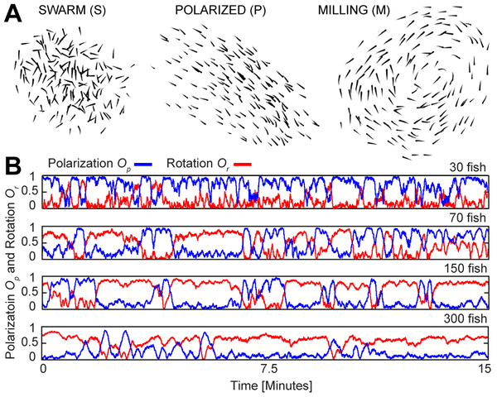

A unity of parts can be so close and intense that it is more then the sum of its parts

Position of a school of fish cannot be predicted on the basis of movements of individual fish

chemical imbalance do not allow one to understand depression

**Domains, specific assumptions**

* What phenomental should be investigated or worked with
* How to interact with the world, interviews, experiments, observation
* What kind of knowlrdge to develop: quantitative, qualitative, generalizable, local…
* How to validate knowlerdge: enlarge +compl

# NATURAL LANGUGE PROCESSING (NLP)

Use of computer/machine learnes to process, intepret and generate natual languages

* Machine translation
* Word sense disambiguation
* Part-of-speech taggin
* Sentiment analysis

**Cyberbulling**

Goal: automated detection of cyberbullying in written text

Supervised machine learning

Data from ASK.fm, facebook and youtube…

Annotated vased on guidelines

**Analysis**

reflect on difference between more

* scientific/fundamental
* technological/applied research

SCIENCE AND TECHNOLOGY

Technology & enginerring are

* applied science / puts scientific knowledge to use
* dependent on science
* lower in the hierarchy

Idea gas deep roots

* Aristotle: distinction between science and art-craft

**False advertising**

ingeneers forced to become scientist. Steampower train

now difference has leveled out

valuting technology

science projects need to have societal relevance

move nuance (sfumature) picture of relation between science and techinolgy

no strict distinction between science and techonology.

enginerring involves non-scientific knowledge too

related but not the same

**science**

* descrptive
* ideal of value-neutrality
* understadining
* start from hypoothesis
* more idealized
* abstract

**technology**

* prescriptive (rules, instructions)
* normative (right, wrong)
* create, intervenen, change
* what if - questions
* less idealized
* concrete

AI combines computer science, machine learning, logicl, mathemartcs, philosophy, cognitive scieince, economics, quantum phyiscs, natural languge processing

very heterogeneous

is AI science or technology?